Media Relations Policy

Introduction
Local, state, national and international media are vital partners in achieving the goals of the South Australian Science Teachers Association (SASTA). In order to maximise the advantages of media presentation and minimise the risks of media misrepresentation it is necessary to establish guidelines for how media contacts will be conducted.
It is not the intention of this policy to curb freedom of speech or to enforce strict rules and regulations. Rather, the intention is to establish a framework for achieving an effective working relationship with the media. The organisation welcomes the opportunity to talk to the media and, through them, to debate issues in the public arena.
In dealing with the media, staff, Board members and other volunteers should be conscious that they may be seen as representatives of the organisation and should therefore avoid making comments or participating in photo opportunities that may damage the long-term reputation of SASTA.

Purpose
SASTA works with the media in order to
- advocate for the goals of the organisation
- promote the work of the organisation
- inform the public of the details of the organisation
- assist in fundraising for the organisation
In order to ensure that these purposes can be fulfilled, this policy regulates the choice of people entitled to speak for SASTA.
The media themselves have a vital role to play on behalf of the community in holding SASTA to account for its policies and actions. It is important that they have access to officers and members and to background information to assist them in this role.
To balance this, SASTA must have the capacity to defend itself from any unfounded criticism and will ensure that the public are properly informed of all the relevant facts (if necessary, using other channels of communication).
It is the responsibility of all staff, board members and volunteers to ensure that effective media relations are maintained in order to achieve the aims of SASTA. Naturally, in doing this, certain legal constraints might apply (eg not making comment on current court cases, especially those before a jury).
This policy deals with the day-to-day relationship between SASTA and the media.

Core Policy
SASTA operates on the values of
- Honesty: The organisation will never knowingly mislead the public, media or staff on an issue or news story.
- Transparency: The organisation will promote openness and accessibility in our dealings with the media, whilst complying with the law and maintaining confidentiality when appropriate.
- Clarity: All communications with the media will be written in plain English
- Balance: Information provided to the media by SASTA will as far as humanly possible be objective, balanced, accurate, informative and timely.

SASTA should seek to establish and maintain a good and open relationship with the media. It is important that the organisation works with the media to communicate important public information messages about its work and its goals.
However, contact concerning any significant matter in the name of or on behalf of SASTA should only be made by staff, Board members and other volunteers where:
- They have consulted the EO
- They have the required expertise to speak on the issue under discussion
- They have some experience in media relations.
In general, staff, Board members and volunteers are recommended to exercise extreme caution and to seek guidance from the EO or President.

Authorisation
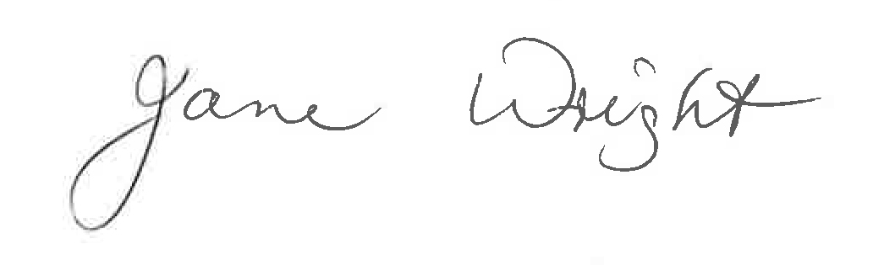
1 March 2021
South Australian Science Teachers Association

Media Relations Procedures

Responsibilities
The EO shall appoint a Marketing and Communications Officer to coordinate SASTA’s relationships with the media.
The Marketing and Communications Officer, EO and the Board President are all authorised to speak on behalf of SASTA.
Other staff, Board members and volunteers are advised to ensure they are properly briefed and guided by the Marketing and Communications Officer, EO or President before talking to the media on any issue related to SASTA.
Where information or public comment is requested or required, the Marketing and Communications Officer shall determine the most appropriate person to respond. In the instance where the Marketing and Communications Officer is not available, this responsibility falls to the EO.
Staff, Board members and other volunteers, and third parties, are encouraged to deliver public presentations that discuss SASTA’s work and its goals, provided that they make it clear where such presentations are or are not authorised by the organisation.

Processes
Significant statements on behalf of SASTA shall be made as authorised by the Marketing and Communications Officer, EO or President as detailed above.
It should always be made absolutely clear whether the views put forward regarding any issue relating to SASTA are those of the organisation or of an individual. At all times consideration should be given as to how the correspondence may affect the reputation of SASTA.
The Marketing and Communications Officer is responsible for:
- Producing and updating a list of key contacts for distribution of media content.
- Producing the organisation’s annual marketing and communications plan, which shall be consistent with the organisation's strategic plan.
- Authorising all media releases from SASTA, and for mounting them on the organisation’s website. All media releases must be checked and approved by the EO before distribution.
- Being involved in any approaches to the media to feature SASTA’s work.
- Receiving and coordinating a response to all approaches from media.
- Sending all final media releases to each member for their information.

All staff, Board members and volunteers are responsible for:
- Ensuring that no photos shall be released to the public via advertising, news media, or internet, or by any other means, without the approval of the Marketing and Communications Officer.
- Notifying the Marketing and Communications Officer of any contact made in the name of SASTA to the media and providing the name of the reporter or writer and the media outlet they represent.
Any significant media contacts with SASTA’s staff or members on any issue likely to prove contentious shall, where possible, be recorded.
Any filming or taping on SASTA’s property or of the organisation’s proceedings by the media is subject to prior permission of the Marketing and Communications Officer, EO or President.
Every effort should be made to assist the media in their inquiries. Where media queries involve requests for information that will require substantial staff work to produce, such work must be authorised by the EO. It will usually be necessary to provide information in addition to that which is requested in order to set the facts and figures in context. Requests for detailed information of this nature, whether from the local or national media, should be referred to the Marketing and Communications Officer.
SASTA reserves the right to withhold certain sensitive information concerning, say, commercial transactions or governmental negotiations. Any such information will be clearly labelled and clearly notified to relevant staff.
If any unauthorised releases of confidential information do occur, an investigation will take place to establish who was responsible and appropriate action will be taken.

Authorisation
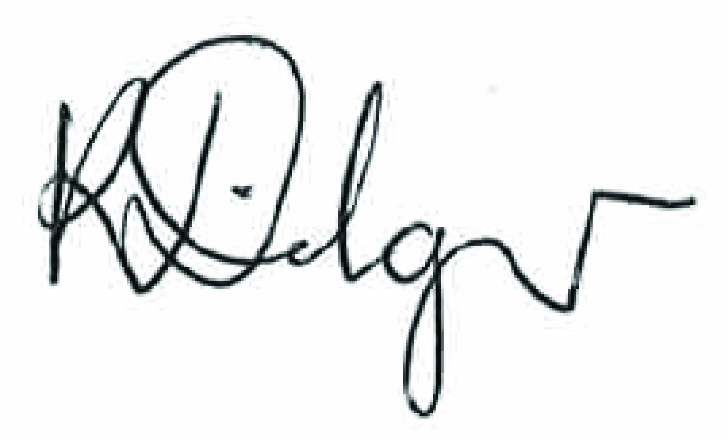
Kate Dilger
1 March 2021

To be reviewed 1 March 2023

