Social media Policy

Introduction
Social media such as Twitter, Facebook, YouTube and blogging represent a growing form of communication for organisations such as the South Australian Science Teachers Association (SASTA), allowing them to engage their members and the wider public more easily than ever before.
However, it is also an area in which rules and boundaries are constantly being tested. This policy acts in conjunction with SASTA’s Media Relations Policy in order to maximise our social media reach while protecting our public reputation.

Purpose
SASTA may choose to engage in social media such as:
- Twitter
- Facebook
- WordPress/Blogger
- YouTube/Vimeo
- iTunes/Podcasting

SASTA seeks to encourage information and link-sharing amongst its membership, staff and volunteers, and seeks to utilise the expertise of its employees and volunteers in generating appropriate social media content.
At the same time, social media posts should be in keeping with the image that SASTA wishes to present to the public, and posts made through its social media channels should not damage the organisation’s reputation in any way.
Due to the fast-moving nature of social media and the constant development of new social media programs, it is important that this policy and its procedures be reviewed at regular intervals.

Core Policy
SASTA’s social media use shall be consistent with the following core values:
- Integrity: SASTA will not knowingly post incorrect, defamatory, or misleading information about its own work, the work of other organisations, or individuals. In addition, it will post in accordance with the organisation's Copyright and Privacy policies.
- Professionalism: SASTA’s social media represents the organisation as a whole and should seek to maintain a professional and uniform tone. Staff, Board members and volunteers may, from time to time and as appropriate, post on behalf of SASTA using its online profiles, but the impression should remain one of a singular organisation rather than a group of individuals.
- Information Sharing: SASTA encourages the sharing and reposting of online information that is relevant, appropriate to its aims, and of interest to its members.

SASTA should seek to grow its social media base and use this to engage with existing and potential members, donors, and stakeholders. At the same time, a professional balance must be struck which avoids placing the organisation’s reputation at risk.

Authorisation
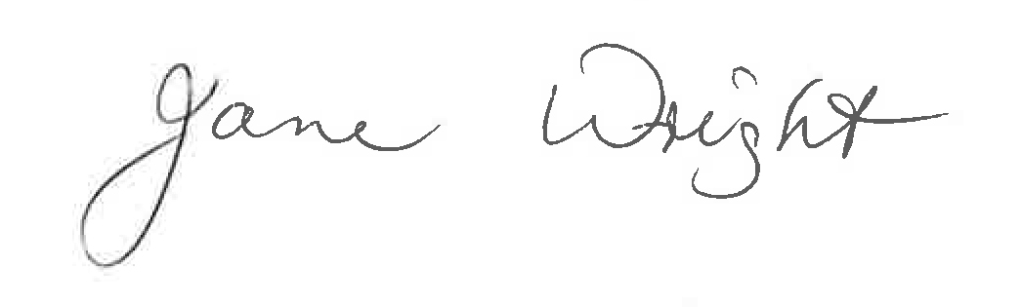
1 March 2021
South Australian Science Teachers Association

social media Procedures

Responsibilities
The EO shall appoint a Marketing and Communications Officer to co-ordinate SASTA’s social media management.
The Marketing and Communications Officer will oversee expansion of social media and help to develop the Social Media Strategy in line with the organisation's Media Relations Policy.
Staff, Board members and volunteers may, from time to time and where appropriate, post on behalf of SASTA using the organisation’s online social media profiles. This is to be done only with the express knowledge and authorisation of the Marketing and Communications Officer.
The Marketing and Communications Officer has ultimate responsibility for:
- Ensuring that all posts are in keeping with SASTA’s core Social Media Policy.
- Ensuring appropriate and timely action is taken to correct or remove inappropriate posts (including defamatory and/or illegal content) and in minimising the risk of a repeat incident.
- Ensuring that appropriate and timely action is taken in repairing relations with any persons or organisations offended by an inappropriate post.
- Moderating and monitoring public response to social media, such as blog comments and Facebook replies, to ensure that trolling and spamming does not occur, to remove offensive or inappropriate replies, or caution offensive posters, and to reply to any further requests for information generated by the post topic.
It is important to maintain the balance between encouraging discussion and information sharing and maintaining a professional and appropriate online presence.

Delegation
Social media is often a 24/7 occupation; as such, such responsibilities as outlined above may be delegated by the Marketing and Communications Officer to another appropriate staff member/volunteer.

Processes
Posting to social media
Before social media posts are made, volunteers and staff should ask themselves the following questions:
- Is the information I am posting, or reposting, likely to be of interest SASTA’s members and stakeholders?
- Is the information in keeping with the interests of the organisation and its constituted aims?
- Could the post be construed as an attack on another individual, organisation or project?
- Would SASTA’s donors/partners/sponsors be happy to read the post?
- If there is a link attached to the post, does the link work, and have I read the information it links to and judged it to be an appropriate source?
- If reposting information, is the original poster an individual or organisation that SASTA would be happy to associate itself with?
- Are the tone and the content of the post in keeping with other posts made by SASTA? Does it maintain the organisation’s overall tone?
If you are at all uncertain about whether the post is suitable, do not post it until you have discussed it with the Marketing and Communications Officer. A few moments spent checking can save the organisation big problems in the future.

Damage limitation
In the event of a damaging or misleading post being made, the Marketing and Communications Officer should be notified as soon as possible, and the following actions should occur:
- The offending post should be removed.
- Where necessary an apology should be issued, either publicly or to the individual or organisation involved.
- The origin of the offending post should be explored and steps taken to prevent a similar incident occurring in the future.
If the mistake seems set to grow, or to cause significant damage to the organisation’s reputation, revert to the Media Relations Policy.

Moderating social media
The reputation of SASTA is first and foremost, and this involves maintaining a safe and friendly environment for its members.
From time to time social media forums may be hijacked by trolls or spammers or attract people who attack other posters or the organisation aggressively. In order to maintain a pleasant environment for everybody, these posts need to be moderated.
Freedom of speech is to be encouraged, but if posts contain one or more of the following, it is time to act:
- Excessive or inappropriate use of swearing
- Defamatory, slanderous, or aggressive attacks on SASTA, other individuals, organisations, projects or public figures
- Breach of copyrighted material not within reasonable use, in the public domain, or available under Creative Commons license
- Breach of data protection or privacy laws
- Repetitive advertisements
- Topics which fall outside the realms of interest to members and stakeholders, and which do not appear to be within the context of a legitimate discussion or enquiry.
If a post appears only once:
- Remove the post as soon as possible
- If possible/appropriate, contact the poster privately to explain why you have removed the post and highlighting SASTA’s posting guidelines.
If a poster continues to post inappropriate content, or if the post can be considered spam:
- Remove the post as soon as possible
- Ban or block the poster to prevent them from posting again.
Banning and blocking should be used as a last resort only, and only when it is clear that the poster intends to continue to contribute inappropriate content. However, if that is the case, action must be taken swiftly to maintain the welfare of other social media users.
The decision to block, ban and remove posts ultimately lies with the Marketing and Communication Officer, but may, at their discretion, be delegated to responsible staff and volunteers.

Authorisation
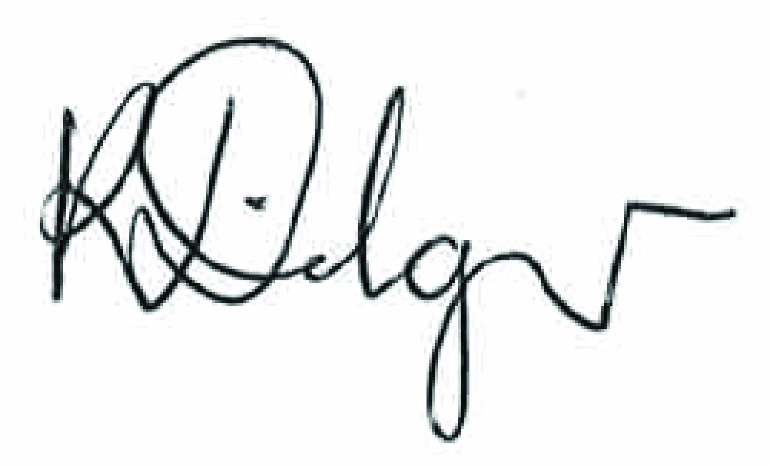
Kate Dilger
1 March 2021

To be reviewed 1 March 2023

