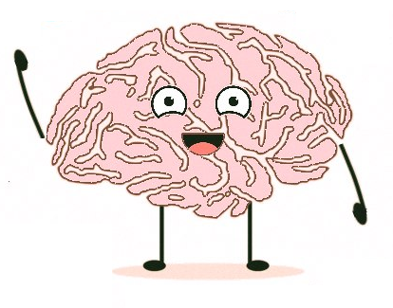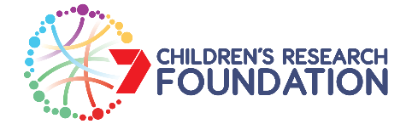

**Benefits to you/your child:**

Participants will receive a $10 gift card for joining a focus group session and the option for your child to be acknowledged as a co-developer in the animation credits.

**Benefits of the study:**

A engaging animation series that normalises having different learning strengths and challenges will promote more inclusive school environments and increase self-esteem in children.

**For more information**

Or contact Dr Amy Wyatt

amy.wyatt@flinders.edu.au

**Participation involves:**

* Providing some basic demographic information about your child
* Providing information about any learning difference or disability that your child experiences (if applicable)
* Your child attending a FUN focus group session (1 hour) conducted by researchers at Flinders University.

**Can your child help us to make an animation series?**

We need kids (7-11 years of age) to help us develop a new animation series that is all about having unique learning strengths and learning challenges.

Children with a learning difference such as autism, ADHD or dyslexia are especially encouraged to apply.

The project is approved by the Flinders University’s Human Research Ethics Committee (Project ID 6114)